4. Connecting the links between climate change and the ocean economy

4.1 Capture fisheries

4.1.1 Importance of capture fisheries to the ocean economy

In 2016, marine capture fisheries produced 79.3 million metric tons (mt) of landings, representing 46.4% of global seafood production (170.9 million mt), and US$130 billion in first sale value (FAO 2018). Approximately 30.6 million people participated (full-time, part-time, or occasionally) in capture fisheries operated by an estimated 4.6 million fishing vessels. Fish and fish products are among the most traded commodities in the world. In 2016, approximately 35% of production entered international trade for either human consumption or non-food uses (FAO 2018). The 60 million mt (USD$143 billion) of fish products exported in 2016 constitute a 245% increase relative to 1976 exports (USD$8 billion). Over this time period, the rate of growth of exports from developing countries has surpassed that from developed countries (FAO 2018). Finally, the average annual increase in fish consumption (3.2%) has outpaced the average annual increase in human population growth (1.6%), and demand for fish is projected to increase as the human population grows and becomes increasingly wealthy (citation).

4.1.2 Impacts of climate change on capture fisheries

The dynamics of harvested marine fish and invertebrate populations are sensitive to climate change (Rijnsdorp et al 2009; Hollowed et al. 2013) via changes in both environmental (e.g., warming, deoxygenation, acidification, etc.) and biological conditions (e.g., changing habitat availability, food webs, predator-prey dynamics, etc.). In some cases, these changes can increase fisheries productivity. For example, warming can expand the suitable thermal habitat range available to a species, or negatively impact a key predator or competitor species. In other cases, these changes can decrease fisheries productivity. For example, hypoxia can increase mortality, acidification can decrease growth rates, and spatial-temporal mismatches in the availability of prey can reduce the recruitment of juveniles and growth. In the section below, we detail how retrospective and forward-looking studies have revealed the impact of climate change on marine fisheries and the opportunity for fisheries management to mitigate the negative impacts of climate change on the ocean economy.

**Climate change modifies the habitat and, therefore, the life history of marine fish and invertebrates, including their growth, natural mortality, and recruitment rates. Fisheries stock assessments and management decisions will have to increasingly account for environmentally-driven changes in fish life history under climate change.**

Observed changes: Climate change has already resulted in reduced growth rates and smaller body sizes in many marine fishes (Sheridan and Bickford 2011), which translates to reduced yield per recruit (Baudron *et al.* 2014) and by extension, reduced catch potential. Climate change has also altered the timing and location of the phytoplankton and zooplankton blooms that support marine food webs (Cushing 1990; Edwards and Richardson 2004; Poloczanska *et al.* 2013). Spatial-temporal mismatches in prey availability have increased mortality rates (Beaugrand *et al.* 2003; Clausen *et al.* 2017) while matches have reduced mortality rates (MacKenzie and Köster 2004). Finally, recruitment of juveniles is often more strongly driven by environmental and ecosystem factors than by spawner biomass (Szuwalski *et al.* 2014; 2019), and has declined as a result of environmental change and overfishing (Britten *et al.* 2016 but see Szuwalski 2016).

Forecasted changes:Fish growth rates and body sizes are expected to decline further under continued warming and deoxygenation, with consequences for catch potential (Cheung 2012 but see Lefevre *et al.* 2017 and Pauly and Cheung 2017 correspondences). On average, maximum body weights are expected to shrink by 14-25% globally from 2000-2050 under a high emission scenario (Cheung 2012). Furthermore, changes in physical oceanography are expected to transport nutrients from surface waters into the deep ocean, driving a 24% reduction in the primary productivity that supports marine food webs by 2300 (Moore *et al.* 2018).

Implications for adaptation: Fisheries stock assessments will increasingly have to account for environmentally-driven, time-varying natural mortality, growth rates, fish concentration locations and recruitment.

**Marine fish and invertebrates are shifting distributions to track their preferred temperatures. Revised transboundary agreements will be necessary to ensure that management remains both effective and equitable as species shift into new management jurisdictions.**

Observed changes: As the oceans have warmed, marine fish and invertebrates have shifted their distributions to track their preferred temperatures (Perry *et al.* 2005; Dulvy *et al.* 2008; Poloczanska *et al.* 2013; Pinsky *et al.* 2013). In general, this has resulted in shifts poleward and into deeper waters. At a rate of 72 km per decade, marine species have been shifting an order of magnitude faster than terrestrial species (Poloczanska *et al.* 2013). These distribution shifts have already presented management challenges (Pinsky *et al.* 2018). For example, a “mackerel war” erupted in 2007 when the northeast Atlantic mackerel stock shifted from waters managed by the European Union, Norway, and Faroe Islands into Icelandic and Greenland waters. Disagreements over the drivers of the shift, the expected duration of the shift, and appropriate catch reallocations resulted in the stock becoming increasingly overfished (Spijkers and Boonstra 2017).

Forecasted changes: The rate of distribution shifts and associated management conflicts are forecast to increase under climate change. All studies forecast generally poleward shifts in species distribution and productivity under continued warming (Cheung *et al.* 2008; 2010; Blanchard *et al.* 2012), often with a decrease of species diversity in equatorial regions, an increase in diversity in poleward regions, and the subsequent formation of novel marine communities (García Molinos *et al.* 2015; Cheung *et al.* 2016). These shifts are likely to increase the risk of management conflicts over transboundary stocks. For example, 23% to 35% of exclusive economic zones (EEZs) are expected to receive a new stock by 2100 under strong greenhouse gas mitigation (RCP 2.6) to business-as-usual mitigation (RCP 8.5) scenarios, respectively (Pinsky *et al.* 2018).

Implications for adaptation: Establishing or strengthening transboundary fisheries management institutions will be necessary to ensure that management remains both effective and equitable as fish stocks shift into new management jurisdictions.

**Although the net global impacts of climate change on fisheries productivity (catch potential) may be modest, regional impacts are likely to be stronger, with pronounced winners and losers. Vulnerable regions must be a focus of management reform and adaptation. Resilience to climate change can be enhanced by preventing overfishing, rebuilding overfished stocks, and accounting for shifting productivity in assessment and management.**

Observed changes: Over the past eighty years, ocean warming has driven a 4.1% decline in the maximum sustainable yield (MSY), the maximum amount of catch that can be harvested for perpetuity, of 235 out of how many of the world’s largest industrial fisheries (Free et al. 2019). In five regions, including the North Sea and ecosystems of East Asia, losses in MSY have ranged 15-35%. Meanwhile, the Baltic Sea and other regions have seen increases in MSY up to 15%. Analyses of historical changes in juvenile recruitment, another metric of productivity, yield conflicting results (Britten *et al.* 2016; Szuwalski 2016), and are also difficult to interpret in terms of food and income security. Well-managed fisheries have been the most resilient to ocean warming while overexploited fisheries have been the most vulnerable (Free et al. 2019).

Forecasted changes: Net global catch potential is not expected to change considerably under climate change (though see RCP 8.5 results below), but strong regional impacts are expected to result in pronounced equatorial “losers” and poleward “winners”. For example, Cheung *et al.* (2010) project modest changes in global catch potential of +1% and -1% from 2005-2055 under low and high emissions scenarios, respectively. Gaines *et al.* (2018) project modest changes in global MSY of +1%, -1%, and -5% from 2012-2100 under RCPs 2.6, 4.5, and 6.0, but forecast a considerable decline of -25% under RCP 8.5. Cheung *et al.* (2010) predict 30-70% increases in catch potential in poleward regions and 40% decreases in equatorial regions, with similar patterns predicted by Gaines *et al.* (2018). The redistribution of catch potential will drive a concomitant redistribution of revenues (Lam *et al.* 2016) and nutrition (Golden *et al.* 2016).

Implications for adaptation: First, preventing overfishing and rebuilding overfished stocks will enhance stock resilience to climate change. Second, fish stock assessments and management procedures will need to account for shifting productivity (a.k.a., non-stationary or time-varying population dynamics). This will involve one of many strategies (Pinsky and Mantua 2014) including: (1) using assessments with time-varying productivity; (2) restricting assessments to the current environmental regime; and/or (3) using climate-adaptive harvest control rules.

4.1.3 Ability for management to mitigate the impacts of climate change

Most forecasts of the impacts of climate change on fisheries compare the maximum biological potential for food production today with that in the future (Cheung *et al.* 2010; Lam *et al.* 2016). While this is useful, it fails to consider the effects of human responses (Barange 2019), which could either limit or exacerbate the impacts of climate change on society. The actions of fishers, management institutions, and markets all influence the benefits derived from fisheries (Costello *et al.* 2016) and could mitigate many of the negative impacts of climate change (Gaines *et al.* 2018).

***We present a new analysis (Free et al. in prep) that documents the benefits countries stand to gain by implementing climate-adaptive fisheries management reforms that address both changes in species productivity and distribution due to climate change.***

Methods: We forecasted the distribution and productivity of 779 harvested marine species out to 2100 under two greenhouse gas emissions scenarios (RCPs 6.0 and 8.5), and compared the status of these fisheries and the amount of catch and profits derived from them under climate-adaptive management and business-as-usual management (Free et al. in prep). Under climate-adaptive management, fisheries stock assessments and management procedures account for shifts in productivity, and transboundary institutions maintain management performance as shifts in distribution move stocks into new management jurisdictions. Under business-as-usual management, current (rather than economically optimal) harvest rates are initially applied and are gradually transitioned to open-access as stocks shift into new management jurisdictions. We then measured the extent to which climate-adaptive management would (1) maintain catch and profits into the future and (2) generate catch and profits relative to a business-as-usual management.

Results: Even countries experiencing declines in fisheries productivity and catch potential would derive more catch and profits through climate-adaptive management than through business-as-usual management (**Figure 3**). Furthermore, in many countries, adaptive management would not only reduce the impacts of climate change, but would actually increase catch and profits relative to today (**Figure 3**). Climate-adaptive fisheries management results in greater cumulative profits than business-as-usual management for 99% of countries under both RCPs 6.0 and 8.5. It results in greater cumulative catches than business-as-usual management in 98% and 67% of countries in RCPs 6.0 and 8.5, respectively. Furthermore, under adaptive management, 71% and 45% of countries derive more catch and profits from fisheries in 2100 relative to today under RCPs 6.0 and 8.5, respectively. The impacts of climate change on fisheries and the opportunities and benefits of climate-adaptive fisheries management reforms can be explored for specific countries in this interactive web application: <https://sfg-ucsb.shinyapps.io/fishcast2/>

Implications for adaptation: Improved fisheries management, not to mention fisheries management that accounts for shifts in species distributions and productivity due to climate change, will generate better outcomes than business-as-usual management in all countries, even those hardest hit by climate change. In the section below, we detail seven key recommendations for implementing such reforms.

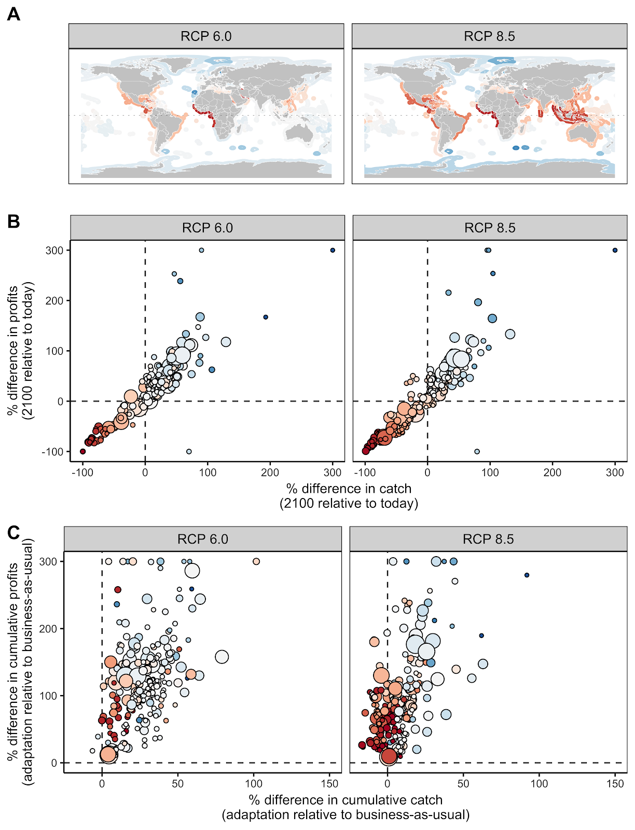

**Figure 3.** Panel **(A)** shows that maximum sustainable yield (MSY) is forecast to decrease in equatorial exclusive economic zones (EEZs) and increase in poleward EEZs through 2100. Panel **(B)** shows that adaptive management results in higher catch and profits in 2100 relative to today for many, but not all, EEZs despite climate change. Panel (**C)** shows that adaptive management nearly always yields more cumulative profits than business-as-usual management and frequently yields more cumulative catches than business-as-usual management.

4.1.4 Recommendations and key conclusions

1. **Eliminate illegal, unreported, and unregulated (IUU) fishing:** IUU fishing is a widespread problem that undermines the effectiveness of fisheries management and reduces climate resilience by promoting overfishing (Agnew *et al.* 2009). By eliminating IUU fishing, countries can rebuild fisheries and increase climate resilience without incurring the short-term reductions in food and income associated with typical reforms (Cabral *et al.* 2018).
2. **Implement best practices in fisheries management:** Best practices in fisheries management, such as science-based harvest control rules and the protection of essential habitat, even when not explicitly climate-adaptive, confer climate resilience through two mechanisms: (1) well-managed fisheries are the most resilient to negative climate impacts (Free *et al.* 2019), and preventing overfishing and rebuilding overfished stocks will enhance climate resilience; and (2) a portfolio of well-managed fisheries buffers fishers against declines in a subset of targeted stocks.
3. **Build resilience by implementing forward-looking, variability-responsive, and adaptive science and management:** Climate change is likely to lead to increased variability and uncertainty in most fishery systems. Management strategies must therefore be adequately responsive to changes in productivities, abundances, and mixes of species, and must prepare for uncertainty and system shocks. In order to design and implement such climate-adaptive management systems:
   1. Management targets and reference points must be revised to be realistic relative to expected future conditions, as historic baselines will no longer be appropriate (Busch *et al.* 2016). Where possible, managers should engage in forecasting, scenario planning, tradeoff evaluation, and other similar exercises to define desired outcomes towards which to manage. In data- and resource- limited settings, highly precautionary and adaptive management strategies should be implemented to account for uncertainty and allow for near-real-time responsiveness to variability.
   2. Fisheries management plans and governing policies should be expanded to promote flexibility and diversification in access to target species, protect “weak stocks,” facilitate the precautionary management of emerging stocks, and to conserve or restore species and functional diversity throughout the system.
   3. Ensure fishery access and allocation systems can accommodate changes in species mix and abundance, as well as socio-ecological change.
4. **Establish and strengthen transboundary institutions and agreements to better manage stocks shifting between jurisdictions:** Pinsky et al. (2018) make the following recommendations: (1) promote data sharing to foster the identification of shifting stocks; (2) use pooled data to inform collaborative management; (3) use side payments to incentivize cooperation and prevent asymmetry in winners and losers; and (4) develop permits that are tradeable across political boundaries to foster dynamic catch allocations.
5. **Use marine protected areas (MPAs) to foster transitions and to buffer against transboundary growing pains:** Networks of MPAs could assist the redistribution of species in response to rapid environmental changes. Furthermore,MPAs placed along country borders could buffer against the degradation of management as stocks shift into new management jurisdictions. The protection offered by MPAs may provide more time for the development of the transboundary institutions and climate-adaptive management methods required to properly manage stocks under climate change.
6. **Build and enhance flexible, polycentric and nested, participatory co-management systems:** Similarly to the way in which best-practice fisheries management can build climate-resilience even when not explicitly climate-focused, implementing “best-practice” co-management and governance systems can build system resilience to undesirable socio-ecological shifts and climate-driven inequities. Representative participatory decision-making systems help to ensure all impacted groups are considered in management thereby reducing drivers of inequity, and flexible, polycentric and nested co-management governance systems help to ensure management decisions match the scale of management challenges (CITE (Ostrom and others)).
7. **Actively address disparities in the distribution of climate impacts that can cause or exacerbate inequity:** Identify existing issues of social vulnerability and differentiated access to power, knowledge and resources, and assess how they might change as the climate changes. Account for vulnerable groups’ need for a change of circumstance to avoid imbalances of power into the future. Prioritize the values and needs of dependent communities in fishery management decision-making, especially around allocation and access to resources.